Duke of Edinburgh Scheme

What is the DofE?
The DofE is a voluntary, non-competitive programme of practical, cultural and adventurous activities, designed to support the personal and social development of young people aged 14-25, regardless of gender, background or ability. It offers an individual challenge and encourages young people to undertake exciting, constructive, challenging and enjoyable activities in their free time.

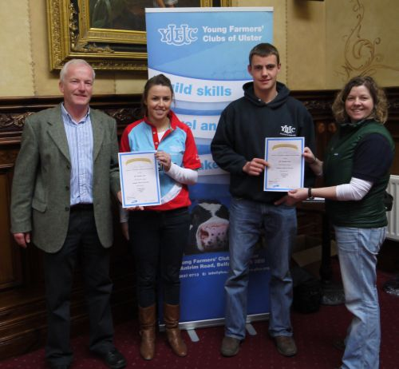
What is involved?
The DofE has three progressive levels:
- Bronze (for those aged 14 and over)
- Silver (for those aged 15 and over)
- Gold (for those aged 16 and over)
And is a four-sectioned programme:
- Volunteering (helping other people in the local community)
- Expedition (training for, planning and completing a journey on foot or horseback, by boat or cycle)
- Skills (covering almost any hobby, skill or interest)
- Physical (sport, dance and fitness)
- Residential (Gold Award only) (a purposeful enterprise with people not previously known to the participant)
You have until your 25th birthday to complete any of the Awards but it takes at least 6 months at Bronze, 12 months at Silver and 18 months at Gold for Direct Entrants.

Timescales
There should be a regular commitment averaging at least an hour a week.

When can I start?
- Bronze Award from 14 Years
- Silver Award from 15 Years
- Gold Award from 16 Years

The Key principles of the Award are:
- achievable by all - a personal challenge not a competition
- available to all - anyone can do it!
- voluntary - it's up to you what you do, it's your leisure time
- personalised - your programme is designed by you for you
- balanced - it will stretch you in all directions
- progressive - you improve at your own pace
- achievement focused - you can't fail
- demands commitment - it takes more than a short burst of enthusiasm
- personal development - it's the taking part that matters; getting an Award is the icing on the cake
- enjoyable - it's about getting out there and having fun!

Using the DofE in YFCU
To take part in the DofE scheme please contact Corrina at HQ on 028 9037 0713 for details

