AQA UNIT AWARD SCHEME
The Young Farmers’ Clubs of Ulster (YFCU) has recently become a National AQA unit award scheme centre.
This allows YFCU to deliver accredited unit award scheme training to its members. From September YFCU members who take part in a range of training activities and competitions currently offered by YFCU will receive a certificate from a recognised examining and awarding body which can be included in their CVs and records of achievement.
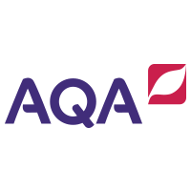
The activities that are available for accreditation are:
- Introduction to Public Speaking
- Dairy stock judging and assessment
- Beef stock judging and assessment
- Sheep stock judging and assessment
- Constructing a stock proof fence
- Participating in a drama performance
- Participating in a choir
- Volunteering as a Club Secretary
- Preparing a Floral Arrangement
- Introduction to Tag Rugby
- Hedge Planting
- Group Debating
These are all activities and competitions that are offered within the annual calendar of events and therefore will require no extra work from the YFCU member apart from participating. To sign up, members can register with their club secretary or directly through YFCU HQ on 9 037 07 13.
A small fee of £10 will be charged and this covers accreditation for all the modules listed above so it is up to the member to decide whether to just do one or all of them for the same price. For more information please contact Kevin Harper at YFCU HQ kevin.harper@yfcu.org

